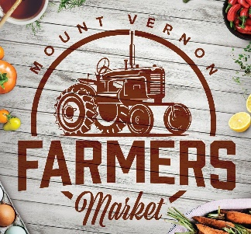 | Mount Vernon  Farmers Market

Vendor Application

Applicant Information
Vendor Business Name:

Primary Contact

Name

 | Address City | State | ZIP Code

Phone: |  | Email

Business Facebook Page or Website

Description of Items sold

INDEMNITY AGREEMENT
Vendors are responsible for the quality and safety of what they sell and agree to not hold Mount Vernon Farmers Market, Mount Vernon Main Street Alliance, and the City of Mount Vernon, including its employees, representatives of volunteers, responsible for any claims arising from the sale of any products, the failure to obtain any necessary licenses or permits, the negligence of any vendor or their employees, representatives or agents, or for any claims and demands for injuries, damages or loss arising out of the sale of my product or my presence on the Market site.

Vendor Statement

By submitting this Vendor Application, I hereby acknowledge that I have read the Mount Vernon Farmers Market Guidelines and agree to abide by them. I further verify that I am responsible to obtain all necessary licenses, permits and have met all requirements to distribute or offer for sale all products listed on this application.

I have read and agree to the above Indemnity Agreement and Vendor Statement. For email applications, if the Authorized Vendor Representative listed below is the same person who sent the email, no signature will be required.

Authorized Vender Representative Date

___________________________________ _____________

APPLICATION SUBMISSION

Completed applications may be submitted using one of the following methods:

Email: MountVernonTXFarmersMarket@gmail.com (preferred for quickest response)

Mail: City of Mount Vernon, Attn: Mount Vernon Farmers Market, P.O. Box 597, Mount Vernon, Texas 75457

You will be contacted to confirm your application was received and of the approval decision. Please note that applying does not guarantee approval. Plan accordingly to allow for enough time for review and approval PRIOR to your first desired attendance date. For same week approval, your application must be received no later than end of day Thursday.

This application process is FREE, and no fees will be assessed for the application or approval to attend the market.

Please email Market Manager, Carolyn Teague, at MountVernonTXFarmersMarket@gmail.com or visit our website to learn more about our market at www.MountVernonTXFarmersMarket.com

For use by Market Manager Only

Application Received __________________________________________

Application Decision __________________________________________

Applicant Informed of Decision __________________________________________

Added to Website _ __________________________________________

